Pass 2 issues:
When you click next, the whole header bar is no longer visible and you have to scroll back up to see it. It should be sticky/fixed. The left hand navigation pane should be sticky/fixed also
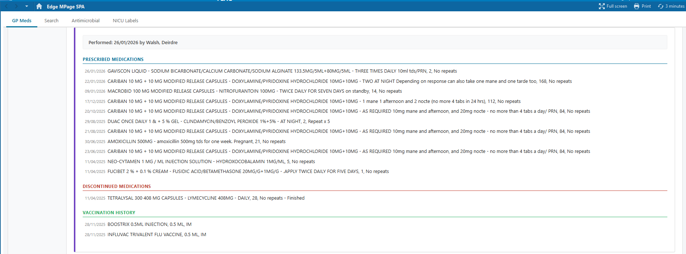
The compare is highlighting identical lines as being changed. This was addressed in the original file
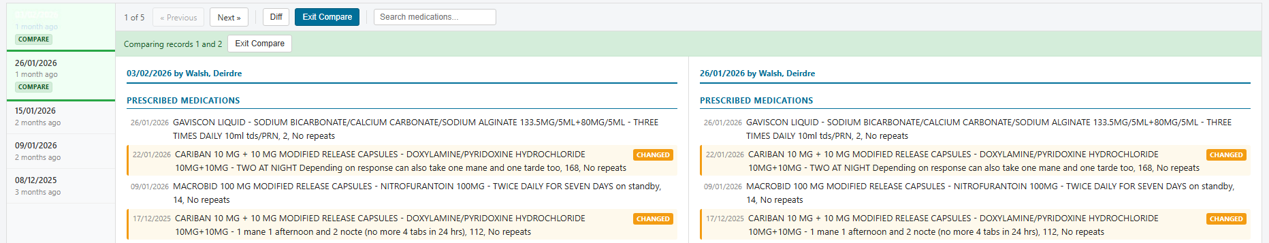
Gaviscon is listed as removed, but compared to the previous record, it should be new
